VBCS Training Lab 04   
Filters on Business Objects and Fusion Apps REST APIs

# Introduction

In this Hands-on Lab, we will take our Course Catalog application and add a filter to the list of classes on our homepage. Since both VBCS Business Objects and Fusion Application REST APIs are based on the same technology, you can use this approach to build filters on lists that connect to either of these types of REST services.

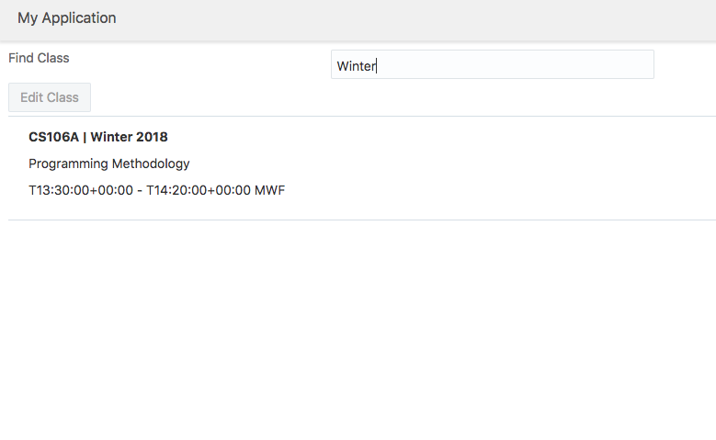

# 

# Hands on Lab Instructions

## Creating a Web Application

1. Click Import button to import a new application
2. Select VBCS-Lab04.zip as the file to import
3. Append your username to the Application ID to make it unique – i.e. VBCSLab04*MyName*
4. Click Finish

## Add a Text Field Above the List of Classes

1. Open Web Apps > webapp1 > flows > main > pages > start
2. Drag an Input Text field above the Edit Class button
3. Change the label to Find Class

## Define the filterCriteria field on the ServiceDataProvider

1. Click the ../../Screenshots/Screen%20Shot%202018-02-26%20at%209.33.53%20PM.pngbutton in the left panel of the editor for the start page
2. In the code editor, put a new line on line 12 between "responseType": "application:getallClassResponse", and "uriParameters": {
3. Enter the following code in the new line:  
     
    "filterCriteria": [{

"attribute": "name",

"op": "co",

"value": ""

}],  
 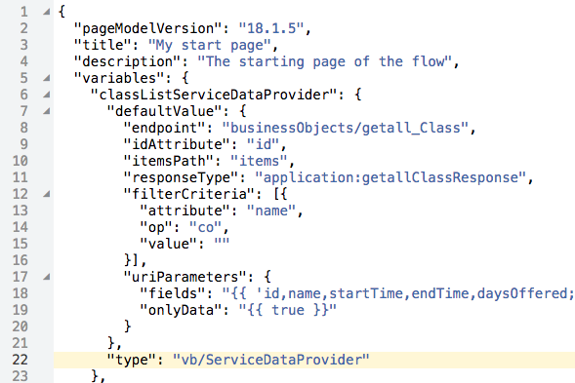

In this code:

* attribute is the field you will be filtering by
* op is the operation. In this case co means contains
* value is the value for which you will filter. We will bind this to the text field we just entered.

## Binding the Search Field to the Filter Criteria

1. Switch back to the Page Designer for the start page.
2. Select the search text field.
3. In the Data tab of the Property Inspector, enter {{ $page.variables.classListServiceDataProvider.filterCriteria[0].value }} in the Value field. Note that filterCriteria is an array so you have to specify the first value in the array.
4. Run the application, enter some text in the search field, and press Enter.  
   

# Conclusion

Oracle Visual Builder Cloud Service is one of the fastest ways to develop and deploy an application to nearly any platform. Whether you are a seasoned application developer or have no technical background at all, VBCS gives you the ability to work with and share data more efficiently than ever before.

Be sure to visit the Oracle VBCS web site to get the latest details about this revolutionary application development tool and many other Oracle Cloud offerings.

<https://cloud.oracle.com/visual-builder>